Dual Persistent Entity Bean

An EJB developer needs to write entity bean components that support both CMP and BMP.
How can an entity bean be designed to support either CMP or BMP at deploy-time?
The environment in which an entity bean component will be deployed in can vary widely from project to project. In the best case, a team will have access to an application server with a good CMP implementation, which they can use to gain significant performance enhancements that are not possible when using BMP. Often a team will be using an application server with poor CMP support or lack of support their database. In this case, BMP is a requirement. This puts an entity bean component developer in a tough situation. How can they provide a component that can fit both situations?
On way to achieve this is to ship two separate versions of the same entity bean component. One packaged for CMP, the other for BMP. Unfortunately, this approach would require that the component developer maintain two separate code bases/components, making testing, debugging, and maintenance more difficult.
A truly portable EJB component should be deployable in any J2EE compliant server, in a wide variety of environments and configurations. By portable, this means that the component should be customizable without any re-programming or compiling. The only source of modification should be the deployment descriptors.
Therefore,
Write entity beans that support both CMP and BMP, by separating business logic into a CMP compliant superclass and BMP persistence logic into a subclass. Deployment descriptor settings can be used to select between the two at deployment time.
Entity beans can be made to support both CMP and BMP by splitting entity bean logic into two classes: a CMP compliant superclass, and a subclass that extends the superclass implementations of ejbStore, ejbLoad and other methods. This new component can be used to choose its persistence mode at deploy-time, by making minor changes to the standard ejb-jar.xml file.
For example, consider an Account entity bean. The account entity bean contains two attributes: an account id and a balance. It also has three business methods: deposit, withdraw, and balance, and one special finder method: findByBalance(int). As a dual persistent entity bean, the Account entity bean would look like figure X.1.
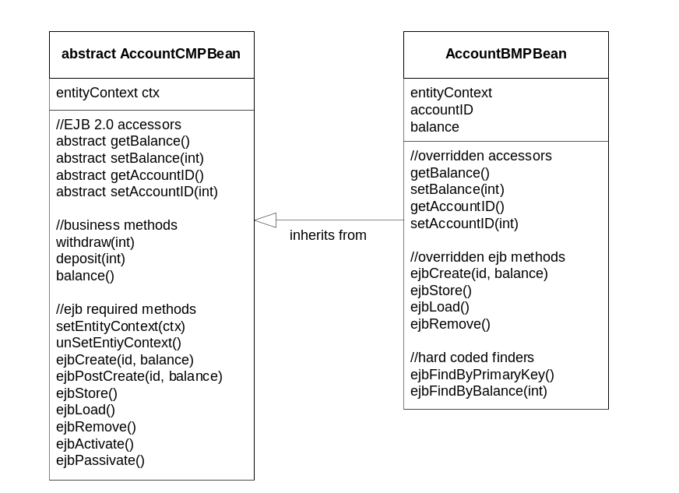
Figure X.1: A Dual Persistent Entity Bean.

1The CMP superclass contains the business methods, and abstract get/set methods (abstract attribute accessors are required by EJB 2.X CMP), and simple implementations of required EJB methods such as set/unSetEntityContext, ejbCreate(). Note that the implementations of ejbLoad, ejbStore, and ejbRemove are empty implementations. Finder methods do not need to be implemented in the CMP class, since these are declared separately in the deployment descriptor.
The BMP subclass provides concrete implementations of the accoundID and balance attributes, and their get/set accessors. Other than that the only extra logic this class requires is real implementations of persistence related methods: ejbCreate, ejbLoad, ejbStore, and ejbRemove. Finder methods also need to be implemented, whereas the CMP superclass relied on query definitions in the ejb-jar.xml file. Note that the BMP does not need to re-implement the business logic methods, set/unSetEntityContext, or ejbActivate/Passivate, since these are inherited from the super class.
At deployment time, the CMP or BMP classes can be chosen simply by changing the ejb-jar.xml file. Specifically, the <ejb-class> tag will need to refer to either the CMP superclass or the BMP subclass. Obviously, the <persistence-type> tag will need to select container or bean managed as well. If choosing CMP, the ejb-jar.xml will need to be configured with CMP specific tags to add a schema, attributes, finders, etc. The schema will also need to be mapped to an underlying data store using the proprietary mechanism provided by the application server being deployed on. On the other hand, if deploying with BMP, the ejb-jar.xml will likely need to add an sql DataSource via the <resource-ref> tags, and that’s it.

Besides creating more portable entity beans, another use of this pattern is for migrating BMP entity beans to CMP. Many pre-EJB 2.0 applications were written in BMP. The CMP support provided by the EJB 1.X specifications were often insufficient for the needs of non-trivial applications, furthermore, many CMP implementations available on the market at the time suffered from poor performance. All of these legacy EJB applications could benefit by moving from EJB 1.X BMP to newer and more sophisticated CMP. Unfortunately, the migration process from BMP to CMP can be very tricky. One solution would be to completely re-write the component using CMP. This option would require a lot more upfront work, and would essentially require cutting and pasting business logic from one entity bean to the other. This is hardly an efficient way to convert BMP beans to CMP. Using the Dual Persistent entity bean pattern, an existing BMP entity bean can be refactored into CMP by creating a superclass and moving code to it, leaving only the attributes, attribute accessors, and persistence related methods in the subclass. The new superclass can be tested and deployed, and the subclass can be removed later if necessary.

Question for reviewers:
Do you think this pattern needs code examples, or is the diagram enough?
Can you think of other reasons to use this pattern or other problems it may solve?
Can you think of a better title for this pattern?

